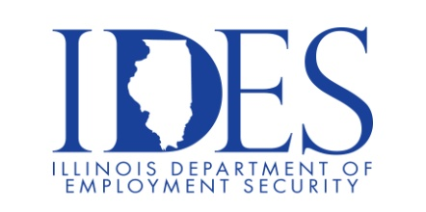

**Are You Looking for a Job?**

**Your Illinois Department of Employment Security Invites You to a   
Job Informational Workshop**

**What:** Essential Employability Skills

**When:** 10 a.m. – 11 a.m. Thursday, August 21, 2025

**Where:** Illinois Department of Employment Security, 1300 S 9th St, Springfield IL 62703

This session is presented by the Illinois Department of Employment Security staff and will explore helpful tips and techniques to increase ways to be more successful in your Job Search.

Please join us as we discuss ways to develop additional opportunities to land the career you want.

Workshop Topics Include:

* What are essential employability skills?
* Why are these skills important to employers?
* Examples of essential employability skills, and how to exhibit them on the job

This event is sponsored by the Illinois Department of Employment Security

**Make Sure Your Resume is on Illinoisjoblink.com**

Illinois businesses are hiring. And they are looking for workers on [Illinoisjoblink.com](http://www.illinoisjoblink.com/) The state’s hiring board features more than 100,000 help-wanted ads. Job seekers can build multiple resumes to emphasize different skills and experiences. Business owners can use keyword matching technology to search resumes and find the best candidate. Illinoisjoblink.com is free for workers and employers. It compares favorably to private efforts that cost hundreds of dollars. No-cost HR recruitment services are available at the website and at (877) 342-7533.

**[](https://illinoisjoblink.illinois.gov/ada/default.cfm)**

***Find a Job/Find an Employee***