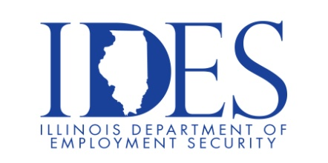

Veterans Resource Fair at The HUB in Marion

What: Veterans Resource Fair
When: September 5, 2025 9AM – 11AM
Where: The HUB, 917 W. Main St., Marion, IL 62959

Learn about resources available to veterans and spouses.
VA Support Services
Community Resources
VA Benefits
Enroll for VA Health Care

Sponsored by Marion VA Health Care System, The HUB, City of Marion, and IDES.

Make Sure Your Resume is on Illinoisjoblink.com
Illinois businesses are hiring. And they are looking for workers on Illinoisjoblink.com Business owners can use keyword matching technology to search resumes and find the best candidate. Illinoisjoblink.com is free for workers and employers. It compares favorably to private efforts that cost hundreds of dollars. No-cost HR recruitment services are available at the website and at (877) 342-7533.



Find a Job/Find an Employee

