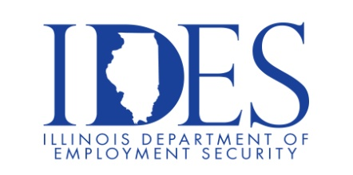
VA Suicide Prevention Summit

What: Veterans Suicide Prevention Summit
When: September 4, 2025 8AM – 3:30PM
Where: The Pavilion, 1602 Sioux Dr., Marion, IL 62959

For Veterans, their families and those who provide care to our nation’s heroes.
Hear Veterans share their stories.
Learn about VA efforts regarding suicide prevention.
VA and community resources will be available during the summit.

Sponsored by Marion VA Health Care System.

Make Sure Your Resume is on Illinoisjoblink.com
Illinois businesses are hiring. And they are looking for workers on Illinoisjoblink.com Business owners can use keyword matching technology to search resumes and find the best candidate. Illinoisjoblink.com is free for workers and employers. It compares favorably to private efforts that cost hundreds of dollars. No-cost HR recruitment services are available at the website and at (877) 342-7533.



Find a Job/Find an Employee

