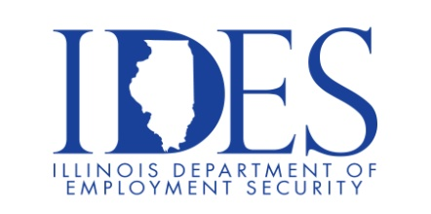

Reach your career goals! Achieve Success!
Free Employment Readiness Workshops!

Find out how you can get the job you DESERVE!

What: Employment Readiness workshops.
When: October 8, 2025 from 10:00 AM – 12:00 AM – Interview Skills
12:30 AM – 2:30 PM –Marketing Yourself to Employers

Where: Marion VA Medical Center, Behavioral Health Building, Room #151
2401 West Main Street Marion, IL 62959-1165

These employment focused workshops are designed to help individuals obtain the career they desire. Professional instructors and free workbooks are supplied. There is no fee to attend.

This event is sponsored by IDES and OBTT.

Make Sure Your Resume is on Illinoisjoblink.com
Illinois businesses are hiring. And they are looking for workers on Illinoisjoblink.com The state’s hiring board features more than 100,000 help-wanted ads. Job seekers can build multiple resumes to emphasize different skills and experiences. Business owners can use keyword matching technology to search resumes and find the best candidate. Illinoisjoblink.com is free for workers and employers. It compares favorably to private efforts that cost hundreds of dollars. No-cost HR recruitment services are available at the website and at (877) 342-7533.



Find a Job/Find an Employee

