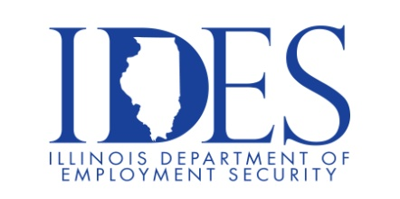

You are Invited to Attend the Red Bud Industries Hiring Fair

Red Bud Industries Hiring Fair
Tuesday, October 21, 2025, 3:00 pm – 7:00 pm
Red Bud Industries
200 B&E Industrial Dr.
Red Bud, IL

Join us at our upcoming hiring fair to learn more about Red Bud Industries, meet our team, and explore exciting career opportunities.
There will be opportunities for on-site interviews, don't miss your chance to find the right fit for your future!

This event is sponsored by Red Bud Industries and the Illinois Department of Employment
Security

Make Sure Your Resume is on Illinoisjoblink.com
Illinois businesses are hiring. And they are looking for workers on Illinoisjoblink.com Business owners can use keyword matching technology to search resumes and find the best candidate. Illinoisjoblink.com is free for workers and employers. It compares favorably to private efforts that cost hundreds of dollars. No-cost HR recruitment services are available at the website and at (877) 342-7533.



Find a Job/Find an Employee

