  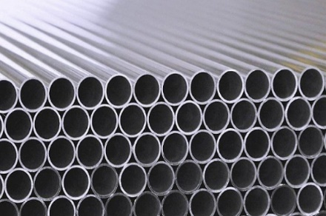
  No
  Appointment
  Necessary
  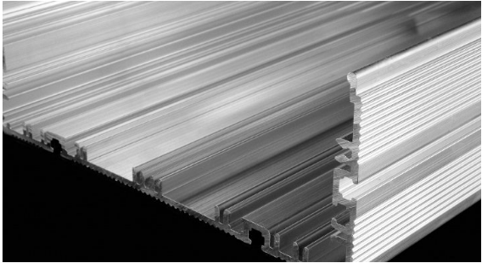
  Come Apply
  To Join Our Team
  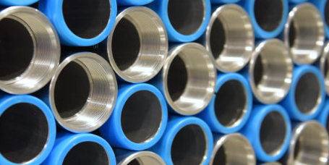
  Come ready to be interviewed
    - Penn aluminum
  open interviews
  “Let’s Talk Tuesdays”
  Tuesday, November 4th, 2025
  FROM 12pm-2pm
  - Competitive Wages
  - Flexible scheduling-3 shifts
  - Extra Pay Available: Shift Differential, Referral Bonuses Attendance Bonus, Incentive Pay
  - Benefits available on day #1
  - Vacation & Holiday Pay
  - 401K
  **If you were previously employed by or worked as a staffing employee at Penn Aluminum and were terminated for any reason or you abandoned the job, you are not eligible for rehire.
  Starting wage $18.18
  Pay Increase after 30 days
  $20.36-$24.62
  advancement opportunities
  be part of a winning team!
  core values-precision, innovation, care, integrity & accountability
  join our diverse and growing team
  A
  Attendance is important!!
  Penn Aluminum
  1117 N 2nd St
  Murphysboro, IL 62966
  Ph: 618-684-2146
  www.pennaluminum.com

