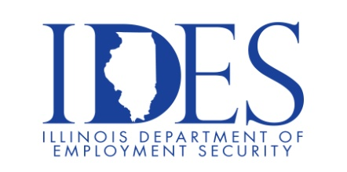

Walker’s Bluff Casino Resort is Hiring!

What: Walker’s Bluff Casino Resort Hiring Event
When: Saturday, October 18, 2025, 2:00 p.m. – 6:00 p.m.
Where: Walker’s Bluff Event Center
777 Walkers Bluff Way
Carterville, IL

We are looking for team members that create a positive and memorable experience with our guests. As an Elite Casino Resort, Walker's Bluff Casino Resort is happy to provide a number of benefits to our employees intended to meet the many needs of our diverse employee population. We offer a comprehensive benefits package that helps our employees get and stay healthy, plan for their future and maintain a healthy work-life balance.

For more information call 618-993-7777 or visit walkersbluffcasinoresort.com.

This event is sponsored by Walker’s Bluff Casino Resort and The Illinois Department of Employment Security.

Make Sure Your Resume is on Illinoisjoblink.com
Illinois businesses are hiring. And they are looking for workers on Illinoisjoblink.com The state’s hiring board features more than 100,000 help-wanted ads. Job seekers can build multiple resumes to emphasize different skills and experiences. Business owners can use keyword matching technology to search resumes and find the best candidate. Illinoisjoblink.com is free for workers and employers. It compares favorably to private efforts that cost hundreds of dollars. No-cost HR recruitment services are available at the website and at (877) 342-7533.



Find a Job/Find an Employee

