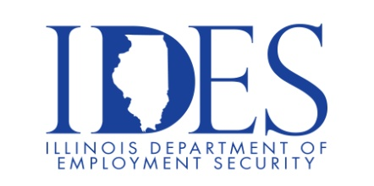

You are invited to the State of Illinois Careers and Federal Careers Workshops!

What: These workshops will provide you with information to help you obtain a great State or Federal Career!
Wednesday, November 19, 2025 10:00 AM – 12:00 PM
Shawnee Community College
8364 Shawnee College Rd.
Ullin, IL

If you are interested in a State or Federal Career, these workshops are for you!!!

10 AM - A representatives with CMS and DCFS will conduct the State Careers Workshop, presenting information on the applications, resumes, interviewing and hiring process as well as navigating the State of Illinois careers website.

11 AM – A representative will conduct the Federal Careers Workshop, presenting information on the applications, resumes, interviewing and hiring process as well as navigating the USAJobs.com website.

This event is sponsored by IDES and CMS.

Make Sure Your Resume is on Illinoisjoblink.com
Illinois businesses are hiring. And they are looking for workers on Illinoisjoblink.com Job seekers can build multiple resumes to emphasize different skills and experiences. Business owners can use keyword matching technology to search resumes and find the best candidate. Illinoisjoblink.com is free for workers and employers. It compares favorably to private efforts that cost hundreds of dollars. No-cost HR recruitment services are available at the website and at (877) 342-7533.



Find a Job/Find an Employee

