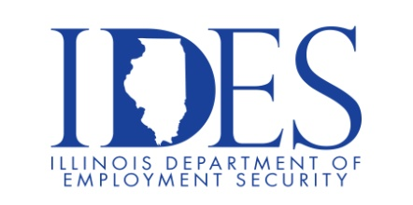
You are invited to Attend the Illinois Dept. of Human Services Murray Developmental Center Career Fair

IDHS will highlight careers and the benefits of working for the State, breakdown the
application process and answer all questions regarding the hiring process.

Murray Developmental Center Career Fair
Tuesday, December 16, 2025, 10:00 am – 12:00 pm
Murray Developmental Center
1535 West McCord St.
Centralia, IL

Open Positions:
- Accountant Supervisor ,Behavior Analysts, Dentist ,Habilitation Program Coordinator, Internal Security Investigator, Maintenance Worker Power Plant
- Mental Health Technicians, Office Associate, Registered Nurses, Social Worker

What to Expect: Overview of jobs and requirements Tips on completing the online application Apply onsite (HR will provide guidance with the application process) No onsite interviews

To Apply Today: www.DHS.STATE.IL.US/JOBS

This event is sponsored by the Illinois Department of Human Services and Illinois Department of Employment Security

Make Sure Your Resume is on Illinoisjoblink.com
Illinois businesses are hiring. And they are looking for workers on Illinoisjoblink.com The state’s hiring board features more than 100,000 help-wanted ads. Job seekers can build multiple resumes to emphasize different skills and experiences. Business owners can use keyword matching technology to search resumes and find the best candidate. Illinoisjoblink.com is free for workers and employers. It compares favorably to private efforts that cost hundreds of dollars. No-cost HR recruitment services are available at the website and at (877) 342-7533.



Find a Job/Find an Employee

