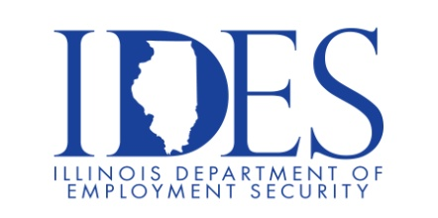
You are invited to Attend the Illinois Dept. of Human Services Alton Mental
Health Center Career Fair

Alton Mental Health Center Career Fair
Tuesday, December 16, 2025, 2:00 pm – 4:00 pm
Alton Mental Health Care Center
4500 College Avenue
Alton, IL
The Illinois Department of Human Services has fulfilling career opportunities in a variety of public service sectors including but not limited to: Public Safety, Human Services, Healthcare, Public Health, Professional Regulation, Business Development and many more. The Illinois Department of Human Services offers career growth potential regardless of your chosen career path.
• Social Services Career Trainee • Registered Nurse • Dietitian • Cook I
• Mental Health Technician • Psychologist
• Rehabilitation Counselor Trainee • Public Aid Eligibility Assistant
• Social Worker II • Hearing & Speech Associate
• Hearing & Speech Specialist • Physician • Psychiatrist • Internal Medicine
• Medical Director • Dentist (I & II) • Information Services Specialist I
• Information Systems Analyst I • Activity Therapist • Office
To Apply Today: www.DHS.STATE.IL.US/JOBS

This event is sponsored by the Illinois Department of Human Services and Illinois Department of
Employment Security.

Make Sure Your Resume is on Illinoisjoblink.com
Illinois businesses are hiring. And they are looking for workers on Illinoisjoblink.com Job seekers can build multiple resumes to emphasize different skills and experiences. Business owners can use keyword matching technology to search resumes and find the best candidate. Illinoisjoblink.com is free for workers and employers. It compares favorably to private efforts that cost hundreds of dollars. No-cost HR recruitment services are available at the website and at (877) 342-7533.



Find a Job/Find an Employee

