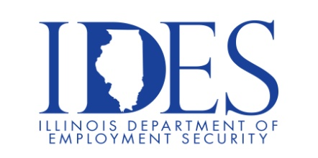

Your Illinois Department of Employment Security Invites You to Attend the Metro Transit Hiring Event

Metro Transit Hiring Event
Friday, January 23, 2026, 10:00 am – 2:00 p.m.
Urban League
Lansdowne Up Center
1800 North 25th St.
East Saint Louis, IL
Looking for a chance to earn more money? Metro Transit is excited to offer part-time bus operator and van operator positions. For part-time operators, drive when it fits your schedule with a variety of shift times available. Please visit our upcoming event for an on-the-spot interview.

This event is sponsored by Metro Transit, Urban League and The Illinois Department of Employment Security.

Business leaders want to know why they should hire you.
How will you make their company more successful?

Make Sure Your Resume is on Illinoisjoblink.com
Illinois businesses are hiring. And they are looking for workers on Job seekers can build multiple resumes to emphasize different skills and experiences. Business owners can use keyword matching technology to search resumes and find the best candidate. Illinoisjoblink.com is free for workers and employers. It compares favorably to private efforts that cost hundreds of dollars. No-cost HR recruitment services are available at the website and at (877) 342-7533.

Find a Job/Find an Employee

