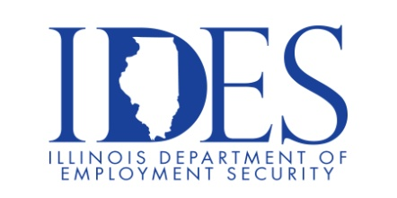

You are Invited to Attend the Penn Aluminum Open Interviews

What: Penn Aluminum Open Interviews
When: Tuesday, March 3, 2026, 12:00 pm – 2:00 pm
Where: Penn Aluminum
1117 North 2nd Street
Murphysboro, IL

Please join us from 12:00 pm - 2:00 pm at Penn Aluminum for
on-the-spot interviews and assessment scheduling.

This event is sponsored by Penn Aluminum and the Illinois Department of Employment
Security

Make Sure Your Resume is on Illinoisjoblink.com
Illinois businesses are hiring. And they are looking for workers on Illinoisjoblink.com The state’s hiring board features more than 100,000 help-wanted ads. Job seekers can build multiple resumes to emphasize different skills and experiences. Business owners can use keyword matching technology to search resumes and find the best candidate. Illinoisjoblink.com is free for workers and employers. It compares favorably to private efforts that cost hundreds of dollars. No-cost HR recruitment services are available at the website and at (877) 342-7533.



Find a Job/Find an Employee

