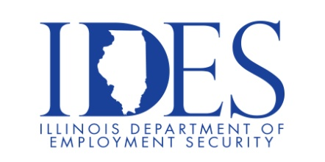
Community Workshops & Events

The Illinois Department of Employment Security Invites You to a
“Resume Development” Workshop

Workshop Topics:
- Understanding Job Postings
- Applicant Tracking System (ATS)
- Resume Types
- Building the Resume/Data Sets
- Job & Career Protfolio
- Cover Letters
- Applications
- Career Fairs
- Translating Military Skills

Thursday, March 12th, 2026
At
11:00 AM

The Workshops will be held Online
Please Pre-Register by clicking the link below:

https://illinois.webex.com/webappng/sites/illinois/webinar/webinarSeries/register/0788111c90c4479ba765872c46076a68

If you find the job search process unclear or just require additional information, please log on to this informational session regarding Resume Development!

If you have any questions or would like additional information, you can reach an Employment Specialist at the local IDES office.
Julie: Julie.Fuesting@illinois.gov
Josh: Joshua.Veach@illinois.gov

Illinois businesses are hiring. And they are looking for workers on Illinoisjoblink.com Job seekers can build multiple resumes to emphasize different skills and experiences. Business owners can use keyword matching technology to search resumes and find the best candidate. Illinoisjoblink.com is free for workers and employers. It compares favorably to private efforts that cost hundreds of dollars. No-cost HR recruitment services are available at the website and at (877) 342-7533.

