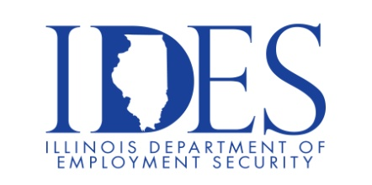

You are invited to Attend the Upcoming Magnificent Seven Job Fair

Magnificent Seven Job Fair
Friday, March 13, 2026, 10:00 am - 1:00 pm
Shawnee Community College Annex Center
2035 Washington Ave
Cairo, IL

Please bring your Resume, Dress Appropriately and Be prepared to be Interviewed.

This event is sponsored by The Illinois Department of Human Services and The Illinois
Department of Employment Security.

AdministratiMake Sure Your Resume is on Illinoisjoblink.com
Illinois businesses are hiring. And they are looking for workers on Illinoisjoblink.com Business owners can use keyword matching technology to search resumes and find the best candidate. Illinoisjoblink.com is free for workers and employers. It compares favorably to private efforts that cost hundreds of dollars. No-cost HR recruitment services are available at the website and at (877) 342-7533.



Find a Job/Find an Employee

Looking to make a lasting impact in your community? The Illinois Department of Human Services offers rewarding career opportunities in various fields - Business, Management and Administration, Medicine and , Healthcare, Community and Social Services, Technology,

