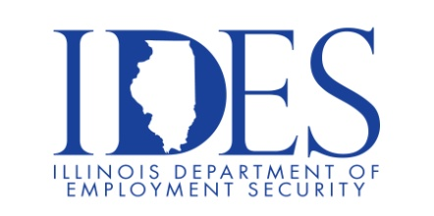
Are You Looking for a Job?

The Illinois Department of Employment Security Invites You to Attend
The Williamson County Job Fair

Williamson County Job Fair
Wednesday, April 15, 2026, 10:00 am – 1:00 pm
Marion VFW
201 East Longstreet Rd.
Marion, IL

Please dress appropriately, be prepared to be interviewed and bring your resume.

This event is sponsored by the Illinois Department of Human Services and the Illinois Department of Employment Security.

Business leaders want to know why they should hire you.
How will you make their company more successful?

Make Sure Your Resume is on Illinoisjoblink.com
Illinois businesses are hiring. And they are looking for workers on Illinoisjoblink.com Business owners can use keyword matching technology to search resumes and find the best candidate. Illinoisjoblink.com is free for workers and employers. It compares favorably to private efforts that cost hundreds of dollars. No-cost HR recruitment services are available at the website and at (877) 342-7533.

Find a Job/Find an Employee

