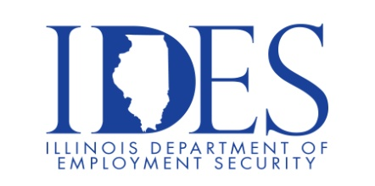

You are Invited to Attend the Heartland Coca-Cola Hiring Event

Heartland Coca-Cola Hiring Event
Wednesday, April 8, 2026, 10:00 am - 2:00 pm
1321 Loxa Road
Charleston, Illinois 61920

This event is sponsored by Heartland Coca-Cola and the Illinois Department of Employment
Security

Make Sure Your Resume is on Illinoisjoblink.com
Illinois businesses are hiring. And they are looking for workers on Illinoisjoblink.com Business owners can use keyword matching technology to search resumes and find the best candidate. Illinoisjoblink.com is free for workers and employers. It compares favorably to private efforts that cost hundreds of dollars. No-cost HR recruitment services are available at the website and at (877) 342-7533.



Find a Job/Find an Employee

