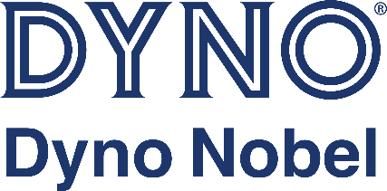

Onsite Hiring Event
April 18, 2026 @ 8:00am
Must apply @ https://www.dynonobel.com/careers/
to be INVITED to the event.
Open Positions: Universal Booster
Operators on 2nd and 3rd Shift

What We Offer:
3 weeks’ vacation + 12 paid holidays + PTO days
Full health benefits including employer HSA contributions + dental plan with an orthodontic option, wellness coaching available
Matching 401K
Generous tuition reimbursement program
Generous paid parental leave
Friendly and supportive coworkers

What We’re Looking For:
High School Diploma or GED preferred
Manufacturing experience preferred - on the job training is provided
Must have a valid driver’s license.
Must be willing to undergo and pass an ATF background check as required to be a possessor of explosives.
Ability to communicate with others effectively verbally
Must be 21 years of age or older​
Must be able to stand, sit, squat, bend and walk through the entire shift. Must be capable of lifting up to 58 lbs. and push/pull 83 lbs.
Ability to wear and care for applicable personal protective equipment (such as, safety glasses and shoes, respirator, face shield, Tyvec, sleeves, gloves, coveralls, safety harness) as required by site specific requirements
Positive attitude, friendly demeanor, and a team player

What You’ll Do:
As the Booster Manufacturing Operator, you will efficiently set-up, fill, inspect and package all Cast Booster products. The operator will ensure safe and timely processing of PETN to supply the demand of booster operations with respect to plant and site-specific safety rules and quality standards. Other duties will include:​
Manufacturing a quality Booster product
Responsible for properly stocking manufacturing areas and preparing products for shipping.
Set up canisters on specific tooling, pouring hot pentolite into canisters and moving carts into cooling tunnels.
Melt down process of transferring melted TNT/Triton from the pre melter into main pots. Will be required to add PETN to main pots per specific formulations and monitoring the process per Standard Operating Procedures.
Will be loading empty plastic or corrugated canisters onto pallets.
Will be cleaning and packing finished product into corrugated boxes for shipping. Stamping Canisters will be required
Must drive a van/box truck to transport products, prepare, operate and unload centrifuge.
You must complete proper documentation and balance while maintaining a clean and organized work area.
Promote implementation of industry best practices, pursue the elimination of waste and support initiatives in manufacturing.
Focus on improving safety and quality and minimizing the impact to current production
Actively participate in a partnership with Maintenance to problem solve safety issues and improve machine up time.
Demonstrate and/or lead the commitment to the pursuit of achieving Zero Harm through behavioral based safety.
Ensure compliance with applicable HSE performance standards, objectives and regulations.

