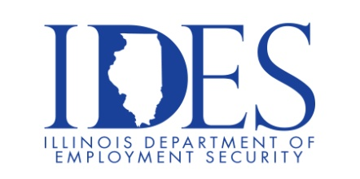

You are invited to Attend the Dyno Nobel Hiring Event

Dyno Nobel Hiring Event
Saturday, April 18, 2026, Begins at 8:00 am
Dyno Nobel Inc.
5570 State Route 3 North Wolf Lake, Illinois

Open Positions: Universal Booster

Operators on 2nd and 3rd Shift
What We Offer:
3 weeks’ vacation + 12 paid holidays + PTO days
Full health benefits including employer HSA contributions + dental plan with an orthodontic option, wellness coaching available
Matching 401K
Generous tuition reimbursement program
Generous paid parental leave
Friendly and supportive coworkers

Make Sure Your Resume is on Illinoisjoblink.com
Illinois businesses are hiring. And they are looking for workers on Illinoisjoblink.com Business owners can use keyword matching technology to search resumes and find the best candidate. Illinoisjoblink.com is free for workers and employers. It compares favorably to private efforts that cost hundreds of dollars. No-cost HR recruitment services are available at the website and at (877) 342-7533.



Find a Job/Find an Employee

