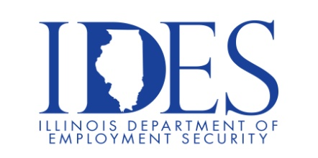

Are You Looking for a Job?

Your Illinois Department of Employment Security Invites You to attend The Innovative Staff Solutions Open Interviews Hiring Event

Innovative Staff Solutions Open Interviews Hiring Event
Every Wednesday in May from 8:00 am – 12:00 pm
Innovative Staff Solutions
238 East Adams St.
Nashville, IL

This event is sponsored by The Illinois Department of Employment Security and Innovative Staff Solutions

Innovative Staff Solutions is currently hiring for the position of General Manufacturing.

Business leaders want to know why they should hire you.
How will you make their company more successful?

Make Sure Your Resume is on Illinoisjoblink.com
Illinois businesses are hiring. And they are looking for workers on Illinoisjoblink.com Business owners can use keyword matching technology to search resumes and find the best candidate. Illinoisjoblink.com is free for workers and employers. It compares favorably to private efforts that cost hundreds of dollars. No-cost HR recruitment services are available at the website and at (877) 342-7533.



Find a Job/Find an Employee

