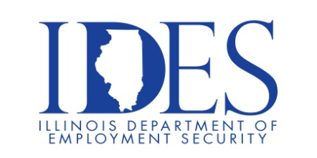

The Illinois Department of Employment Security and Pepsi Mid-America invite you to Attend the Pepsi Mid-America Open Interviews.

Pepsi Mid-America Open Interviews
Thursday, July 9, 2026, 1:00 pm – 4:00 pm
Breese Library
530 North 3rd Street
Breese, IL

Please Dress Appropriately and Be Prepared to be Interviewed

This event is sponsored by the Illinois Department of Employment Services and Pepsi Mid-America.

Make Sure Your Resume is on Illinoisjoblink.com
Illinois businesses are hiring. Job seekers can build multiple resumes to emphasize different skills and experiences. Business owners can use keyword matching technology to search resumes and find the best candidate. Illinoisjoblink.com is free for workers and employers. It compares favorably to private efforts that cost hundreds of dollars. No-cost HR recruitment services are available at the website and at (877) 342-7533.



Find a Job/Find an Employee

