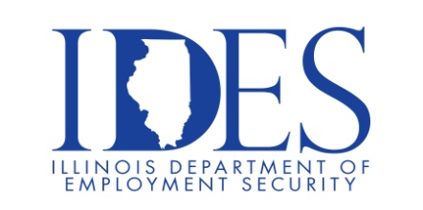

You are invited to the State of Illinois Careers and Federal Careers Workshops!

State of Illinois Careers and Federal Careers Workshops
Tuesday, July 21, 2026, Begins Promptly at 10:00 am
Rend Lake Community College
Murphy Wall Campus
5680 State Route 154
Pinckneyville, IL

If you are interested in a State or Federal Career, these workshops are for you!!!

10 AM - A representative with CMS will conduct the State Careers Workshop, presenting information on the applications, resumes, interviewing and hiring process as well as navigating the State of Illinois careers website.

11 AM – A representative will conduct the Federal Careers Workshop, presenting information on the applications, resumes, interviewing and hiring process as well as navigating the USAJobs.com website.

This event is sponsored by IDES and CMS.

Make Sure Your Resume is on Illinoisjoblink.com
Illinois businesses are hiring. And they are looking for workers on Illinoisjoblink.com The state’s hiring board features more than 100,000 help-wanted ads. Job seekers can build multiple resumes to emphasize different skills and experiences. Business owners can use keyword matching technology to search resumes and find the best candidate. Illinoisjoblink.com is free for workers and employers. It compares favorably to private efforts that cost hundreds of dollars. No-cost HR recruitment services are available at the website and at (877) 342-7533.



Find a Job/Find an Employee

