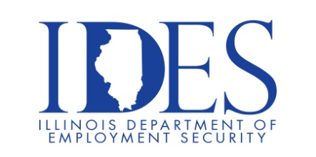
You are Invited to Attend the Urban League Expo

Urban League Expo
Friday, August 7, 2026, 10:00 am - 2:00 pm
Urban League Regional Headquarters
1408 North Kings highway
Saint Louis, Mo

What to expect:

Employment & interview opportunities

Workforce development & training programs

Financial literacy & supportive services

Health & wellness resources

Community-based programs & services

Resident engagement opportunities

This event is sponsored by Urban League Strategies and the Illinois Department of Employment Security.
Make Sure Your Resume is on Illinoisjoblink.com
Illinois businesses are hiring. And they are looking for workers on Illinoisjoblink.com. Job seekers can build multiple resumes to emphasize different skills and experiences. Business owners can use keyword matching technology to search resumes and find the best candidate. Illinoisjoblink.com is free for workers and employers. It compares favorably to private efforts that cost hundreds of dollars. No-cost HR recruitment services are available at the website and at (877) 342-7533.



Find a Job/Find an Employee

