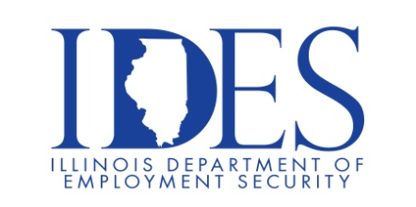
You are invited to Attend the Illinois Dept. of Human Services Alton Mental Health Center Career Fair

Alton Mental Health Center Career Fair
Tuesday, August 18, 2026, 2:00 pm – 4:00 pm
Alton Mental Health Care Center
Willow Building – Dining Room
4500 College Avenue
Alton, IL

The Illinois Department of Human Services has fulfilling career opportunities in a variety of public service sectors including but not limited to: Public Safety, Human Services, Healthcare, Public Health, Professional Regulation, Business Development and many more. The Illinois Department of Human Services offers career growth potential regardless of your chosen career path.

Open Positions:
Security Therapy Aide Trainee, Registered Nurse - 12 HR Shift
Mental Health Technician Trainee, Licensed Clinical Social Worker
PSA / Clinical Nurse Manager (Various), Psychiatrist
Clinical Psychologist, Office Associate and other Admin Support Jobs
Activity Therapist, Mental Health Support Recovery Specialist I
Security Officer, Stationary Engineer
Maintenance Equipment Operator/Driver
Support Service Worker - Dietary & Housekeeping, Cook I

Contact Us: DHS.Recruitment@Illinois.gov

This event is sponsored by the Illinois Department of Human Services and Illinois Department of Employment Security

Make Sure Your Resume is on Illinoisjoblink.com
Illinois businesses are hiring. And they are looking for workers on Illinoisjoblink.com Job seekers can build multiple resumes to emphasize different skills and experiences. Business owners can use keyword matching technology to search resumes and find the best candidate. Illinoisjoblink.com is free for workers and employers. It compares favorably to private efforts that cost hundreds of dollars. No-cost HR recruitment services are available at the website and at (877) 342-7533.



Find a Job/Find an Employee

