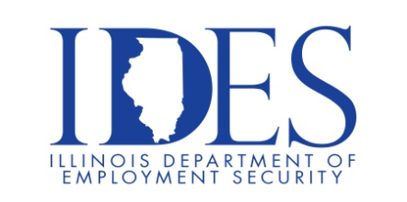

You are Invited to Attend the Hershey Job Fair

Hershey Job Fair
Tuesday, September 15, 2026, 10:00 am – 1:00 pm and 3:00 pm – 7:00 pm
Robinson Civic Center
300 South Lincoln St.
Robinson, IL

Operators, Warehouse, General Labor and Maintenance openings
Competitive benefits package includes:
- Competitive Pay Starting at $24.00/hr
- Additional Pay Increase after successful training
- Shift Premiums Available (2nd & 3rd)
- Health, Dental & Vision Coverage & more (starting 1st day)
- 401(K) Retirement Plan
- Paid Time Off & Holiday Pay & more
- Career Growth Opportunities

This event is sponsored by Hershey and the Illinois Department of Employment Security

Make Sure Your Resume is on Illinoisjoblink.com
Illinois businesses are hiring. And they are looking for workers on Illinoisjoblink.com. Job seekers can build multiple resumes to emphasize different skills and experiences. Business owners can use keyword matching technology to search resumes and find the best candidate. Illinoisjoblink.com is free for workers and employers. It compares favorably to private efforts that cost hundreds of dollars. No-cost HR recruitment services are available at the website and at (877) 342-7533.

Find a Job/Find an Employee

