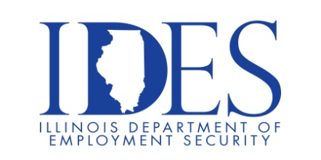

You are Invited to Attend the Saline County Job Fair

Saline County Job Fair
Friday, October 2, 2026, 9:00 am – 12:00 pm
Harrisburg Lions Club
1400 South Main St.
Harrisburg, IL

Please Dress Appropriately and Be prepared to be Interviewed.

This event is sponsored by the Illinois Department of Human Services and the Illinois Department of Employment
Security

Make Sure Your Resume is on Illinoisjoblink.com
Illinois businesses are hiring. And they are looking for workers on Illinoisjoblink.com Business owners can use keyword matching technology to search resumes and find the best candidate. Illinoisjoblink.com is free for workers and employers. It compares favorably to private efforts that cost hundreds of dollars. No-cost HR recruitment services are available at the website and at (877) 342-7533.



Find a Job/Find an Employee

