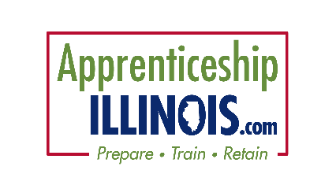
Apprenticeship illinois committeE

Marketing Work group
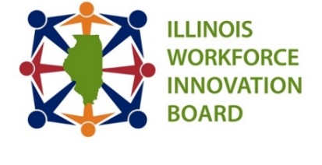
Date: Thursday, Feb 3 Time: 2:00-3:00 pm
Location:
NEED TO ADD

Members:

Chair: Tony Fuhrmann, Madison County Employment & Training
Cyndi Bergstein – Chicagoland Workforce Funders Alliance
Arthur Bishop, Safer Foundation
Patrick Campbell, DCEO-OET
Michele Velez, IDHS, DRS
Mike Conley – Committee Chair, Trenton Sun and SWIC
David Girzadas – City Colleges of Chicago
Jan Keresztes – Accreditation Council of Pharmacy Education
Kindy Kruller – Cook County Bureau of Economic Development

Danielle Kuglin Seago, Project Hire-Ed, DuPage
Kathy Meisinger – Elgin Community College
Lee Reese – St. Clair County Intergovernmental Grants Department
Shay Robinson, Aon
Craig Schmidt, Calumet Area Industrial Council
Daniel Serota, Aon
Sheree Speakman – Accreditation Council of Pharmacy Education
Tom Wendorf*, IWIB Business Engagement Committee, Co-Chair
STAFF: Jennifer Phillips, ISU-ICSPS, Kim Kuchenbrod, ISU-ICSPS, David Garvey, Illinois workNet support
*NEW MEMBER 2022

Time | Item | Presenter
2:00 | Welcome | Tony Fuhrmann
2:05 | Social Media, Monthly Email Update & Website Analytics | David Garvey
2:15 | Update on LEAP Congressional Briefing | Daniel Serota
2:25 | WIOA Summit – report on sessions submitted | Tony Fuhrmann
2:35 | Industry-focused Webinar Series for Employers: March | Sheree Speakman/Lee Reese
2:50 | Update on DCEO Marketing and Outreach Resources
2:55 | Announcements/New Business | All
3:00 | Adjournment | Tony Fuhrmann
NEXT Meeting: Mar 3, 2021 @ 2:00 PM
Apprenticeship Illinois IWIB Quarterly Committee meeting Mar 17, 9-11 am
2022 Meeting Dates:
April 7, May 5, June 2, July 7, Aug 4, Sept 1, Oct 6, Nov 3, Dec 1
Need to find a document?
Marketing Committee online meetings summaries and materials

2022 Goals (as discussed in October)
- Input/Oversight of marketing resources (from USDOL grant)
- Formalize a Marketing/Outreach plan and possibly hire PR consultant
  - Videos
  - Audience expansion (Chambers/educators/legislators)
  - Inclusive Marketing Strategy/Toolkit (DEI goal)
  - Business Outreach – use RAPIDS employer list to put more logos on the site
  - Success stories
- Sector Webinar Series
- WIOA Summit Apprenticeship Track
- Additions and continuous improvement to website
  - Apprenticeship Data Dashboard – full Committee topic for Dec meeting
  - Youth and Pre-Apprenticeship landing pages)
- Apprenticeship Illinois Annual Report – aim for July release (Jan-June focus)
- Return on Investment Toolkit and other Employer-friendly marketing
- National Apprenticeship Week + In-Person Summit 2022 (June-November focus)

