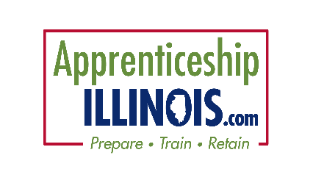
Apprenticeship illinois committeE

Marketing Work group
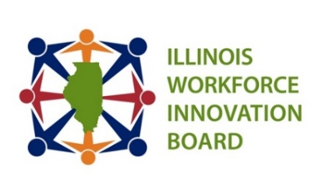
Date: Thursday, August 8, 2024 Time: 2:00-3:00 pm
Location:Zoom

Members:

Chair: Tony Fuhrmann, Madison County Employment & Training
Daniel Serota, Apprenticeship Illinois Committee Chair, Aon
Cyndi Bergstein – Chicagoland Workforce Funders Alliance
Mark Yates, Safer Foundation
David Girzadas – City Colleges of Chicago
Jan Keresztes – Accreditation Council of Pharmacy Education
Jennifer Foil – Center for Governmental Studies NIU
Danielle Kuglin Seago, Project Hire-Ed, DuPage
Lee Reese – St. Clair County Intergovernmental Grants Department
Craig Schmidt, Calumet Area Industrial Council
Sheree Speakman – Accreditation Council of Pharmacy Education
Tom Wendorf, IWIB Business Engagement Committee, Co-Chair
Kara Demirjian Huss – TCCI Manufacturing/DCC Marketing
Mitch Dickey – TRANSFR Inc.
Curt Rendall – Heartland Community College
Sheryl Morris – UNITE HERE Chicago Hospitality Institute
Jamie Corda Hadjaoui – LWIA 23
Marion Batey – Chicago Cook Workforce Partnership
Larry Fitzpatrick – E&ES

STAFF: Kiersten Baer, Jordan Johnson, ISU-ICSPS, Kimberly Heinisch, Illinois workNet support

Time | Item | Presenter
2:00 | Welcome | Tony Fuhrmann
2:00 | OMA Guidelines | Kiersten Baer
2:05 | Marketing Survey | Tony Fuhrmann
2:15 | Marketing Focus Groups | Tony Fuhrmann
2:30 | Website Marketing Update | Kimberly Heinisch
2:40 | Apprenticeship IL Bootcamp | Kiersten Baer
2:45 | NAW | Tony Fuhrmann
2:55 | Public Comment & Questions | Tony Fuhrmann
3:00 | Adjournment | Tony Fuhrmann
NEXT Meeting: September 5, 2024 @ 2 PM
Apprenticeship Illinois IWIB Quarterly Committee meeting
2024 Meeting Dates:
Fall – September 19, 2024 Winter – December 12, 2024

