Communications and Stakeholder

engagement committee (CASE)

Communications Work group
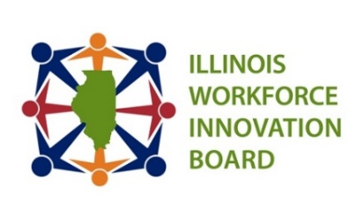
Date: Thursday, August 21, 2025 Time: 2:00 pm
Location: Zoom

Members:

Co-Chair: Tony Fuhrmann, Madison County Employment & Training
Co- Chair: Mitch Dickey – TRANSFR Inc.
Kara Demirjian Huss – TCCI Manufacturing/DCC Marketing, IWIB CASE
Committee, Chair
Alex Purcell – United IWIB CASE
Committee, Vice Chair
Jess Wright – Duravant – MEDICAL LEAVE
Kraig Kistinger – National Tube Supply
Christine Caves – Quad City Chamber
Biswa Puhya – IDHS/DRS
Lavon Nelson – ICCB
Kristie Conklin - Commonwealth Edison

STAFF: Kiersten Baer, ISU-ICSPS, David Gallagher, Christy Montgomery

Goal: To effectively kick off the Communications Workgroup with a focus on prioritization of efforts and the start of three initial projects.
Time | Item | Presenter
2:00 | Welcome + Quroum | Mitch Dickey/Tony Fuhrmann
2:05 | Minutes | Mitch Dickey/Tony Fuhrmann
2:10 | Relationship Inventory – Next Steps | Mitch Dickey
2:55 | Public Comment & Questions | Mitch Dickey/Tony Fuhrmann
3:00 | Adjournment | Mitch Dickey/Tony Fuhrmann
NEXT Communications Workgroup Meeting: 2 PM – 3 PM
September 18th, October 16th, December 18th

IWIB Communications and Stakeholder Engagement Committee Meetings: 9 AM- 10 AM
September 25th, November 20th

2025 IWIB Quarterly Meetings: 1-3 PM September 11th (Moraine Valley Community College, Palos Hills, IL), December 4th (Abraham Lincoln Presdential Library & Museum, Springfield, IL)

Project Timeline:

- July 17th – Approving Logic Model & Outlining First Steps for Relationship Inventory
- August 21st – Progress of Relationship Inventory & Starting Value Proposition
- September 18th – Finish Value Proposition & Review Drafts of Communications (Value propositions Communications) & Starting Outreach for Relationship Inventory

