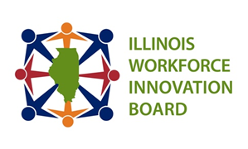
Executive Committee
Date: November 3, 2025
Time: 10:00 AM – 11:00 AM
Chairperson: Marlon McClinton

Members:
Ms. Jennifer Foster |Dr. Brian Durham | Mr. Terry Wilkerson | Mr. Sandeep Nain | Dr. Andrew Warrington |
Mr. Marlon McClinton |Mr. Daniel Serota |Kara Demirjian Huss
Time | Item | Presenter
10:00 AM | Welcome and Introduction | Marlon McClinton
 | Approval of October 6, 2025, meeting minutes
10:05 AM | Update: Federal and State Information, Legislation, and IWIB Reappointments | Lisa Jones and  Julio Rodriguez
10:15 AM | IWIB December Agenda | Aime´e Julian
10:20 AM | Communication and Stakeholder Engagement (CASE) Update | Kara Demirjian Huss
10:27 AM | Continuous Improvement and Accountability (CIA) Committee Update | Marlon McClinton
10:34 AM | Work-Based Learning and Apprenticeship (WBLA) Committee Update | Daniel Serota
10:41 AM | WIOA Annual Report Request to Approve | Drew Thomason
10:53 AM | Old Business:  New Business:  - Legislative Strategies from DECO – December  - Action Items for Legislative Support – January  - Share Summaries of American Talent Strategy and American Action Plan  - Discuss how the system is using AI  WIOA Reauthorization – Updates as they become evident | Marlon McClinton
10:55 AM | Public Comment: | Marlon McClinton
11:00 AM | Adjournment | Marlon McClinton
Next Meeting: November 3, 2025; December 1, 2025, January 12, 2026, February 2, 2026

