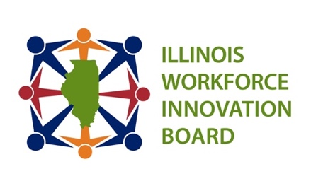
EQUITY TASK FORCE Agenda
Date: 6/23/21
Time: 8:30-10:00 am
Location: Online – See log in Information Below
Chairs: Ms. Elba Aranda-Suh and Dr. Lisa Bly-Jones
Members: Diana Alfaro, Bridget Altenburg, Lawrence Benito, Katherine Blank, Jeremiah Boyle, Nashad Carrington, Peter Creticos, Pat Devaney, Morgan Diamond, Antoinette Golden, Adrian Esquivel, Jamie Ewing, Pastor Ford, Jennifer Foster, LaTanya Law, Jessica Linder-Gallo, Emily Garrity, Laura Gergely, Delmar Gillus, Jr., Teresa Haley, Greg Harle, Jerome Holston, Aime’e Julian, Jason Keller, Jonathan Lanning, Stephanie Lipe, Sergio Mendoza, Angela Morrison, E’Lisa Moss, Clayton Pryor, Magdalena Rivera, Julio Rodriguez, Manny Rodriguez, Carlotta Roman, Emily Rusca, Itedal Shalabi, Daniel Sullivan, Stephanie Veck, Andrew Wells, Tom Wendorf, Laura Wilhelm, Audra Wilson, Esq.

Staff Attendees: Sarah Blalock, Yolanda Clark, Molly Cook, Lisa Jones, Brian Richard, Terah Scott
Time | Item | Presenter
5 min. | Introductions and Remarks | Ms. Elba Aranda-Suh and Dr. Lisa Bly-Jones
5 min. | Approval of Minutes (Action Item)  - February 24, 2021 | Ms. Elba Aranda-Suh and Dr. Lisa Bly-Jones
5 min | Introduce Maher & Maher | Ms. Lisa Jones
10 min | Adoption of Working Vision of Equity and Definition of Equity Lens (Action Item) | Ms. Elba Aranda-Suh and Dr. Lisa Bly-Jones
25 min. | Presentation: Illinois Board of Higher Education | Ms. Ginger Ostro (tent.)
15 min. | Presentation: Data Workgroup Update on Analytical Tool to Track Program Access and Outcomes and Disaggregate Data to Reveal Disparities in Policies and Program Delivery | Ms. Yolanda Clark
15 min. | Work Group Reports and Discussion  - Data Analysis  - Policy  - Program | Ms. Elba Aranda-Suh and Dr. Lisa Bly-Jones  Mr. Dan Sullivan  Mr. Sergio Mendoza and Ms. Angela Morrison  Mr. Adrian Esquivel
5 min. | Next Steps
5 min | Public Comment | Ms. Elba Aranda-Suh and Dr. Lisa Bly-Jones
 | Adjournment | Ms. Elba Aranda-Suh and Dr. Lisa Bly-Jones

Zoom Instructions
Access Meeting: https://illinoisstate.zoom.us/j/97352475375
Call In: Meeting ID: 973 5247 5375
One tap mobile
+13017158592,,97352475375# US (Washington D.C)
+13126266799,,97352475375# US (Chicago)

