Communications and Stakeholder

engagement committee (CASE)

Sector Strategies Work group
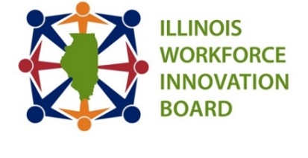
Date: Thursday, Feb. 12th, 2026 Time: 2:00 pm
Location: Microsoft Teams

Members:

Co-Chair: David Boulay- IMEC
Co- Chair: Nicole Bateman - Decatur EDC
Kara Demirjian Huss – TCCI Manufacturing/DCC Marketing, IWIB CASE
Committee, Chair
Alex Purcell – United, IWIB CASE
Committee, Vice Chair
Kraig Kistinger – National Tube Supply
Jennifer Serino – Lake County Workforce Development Dept.
Lavon Nelson – ICCB
Phaedra Leslie – All Construction Group
Bill Wilcox – AISIN
Sarah Hartwick – IMA
Alaina Harkness- Current Water
Mark Harris- Pritzker Talent Lab
Jason Horwitz- DCEO
Greg Feltman- Illinois Quantum and Microelectronics Park
Rick Trujilo- Nicor Gas
Todd Lowery- IDES

STAFF: Christy Montgomery-Jones, AIR, Gina Wells, AIR

Goal: To review initial Sector Strategy Survey Results and review first draft of report early data received by January 16th. *Note, updates may be reflected in report second draft of data received during the survey extension period.
Time | Item | Presenter
2:00 | Welcome + Roll Call | David Boulay/Nicole Bateman
2:05 | September & October 2025 Minutes Approval | David Boulay/Nicole Bateman
2:10 | Sector Strategies Survey Initial Results & First Draft Report Review | David Boulay/Nicole Bateman
2:55 | Public Comment & Questions | David Boulay/Nicole Bateman
3:00 | Adjournment | David Boulay/Nicole Bateman
NEXT Sector Strategies Workgroup Meeting: 2 PM – 3 PM
March 5th, 2026

2026 IWIB Quarterly Meetings: March 12, 2026 9:30 AM – 11:30 AM Location for In-person TBD/ Join by Zoom: https://illinoisstate.zoom.us/j/83385433573?jst=1

IWIB Communications and Stakeholder Engagement Committee Meetings: 9 AM- 10 AM
March 19th, 2026

